**Practical No-2**

**hostname**

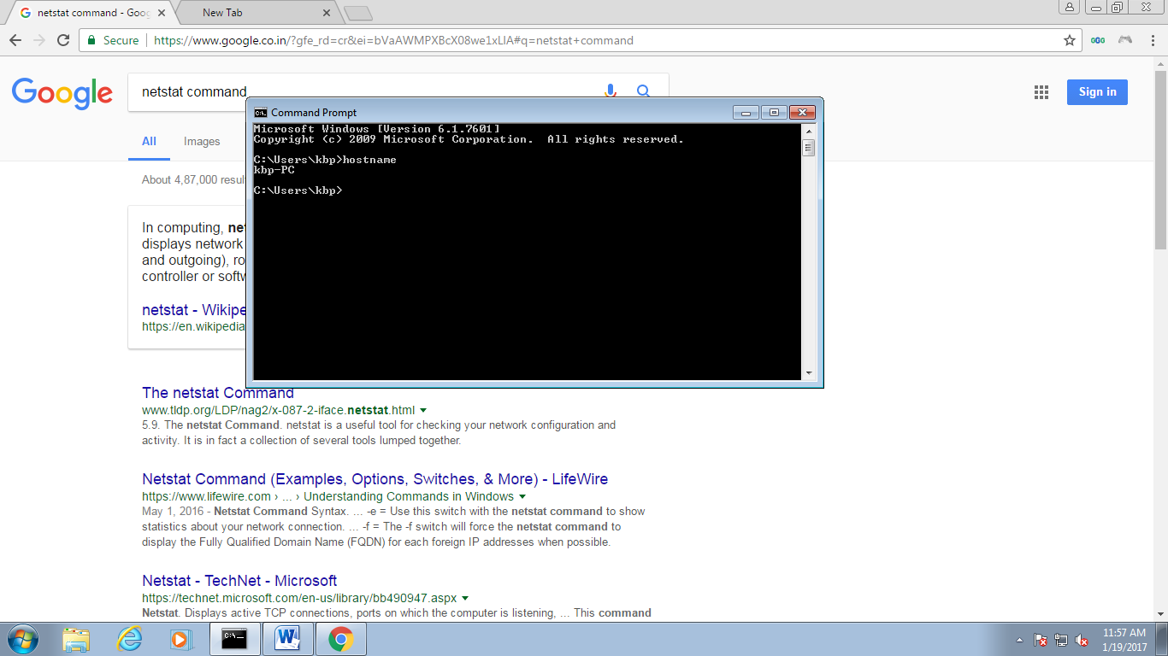

**arp -a**

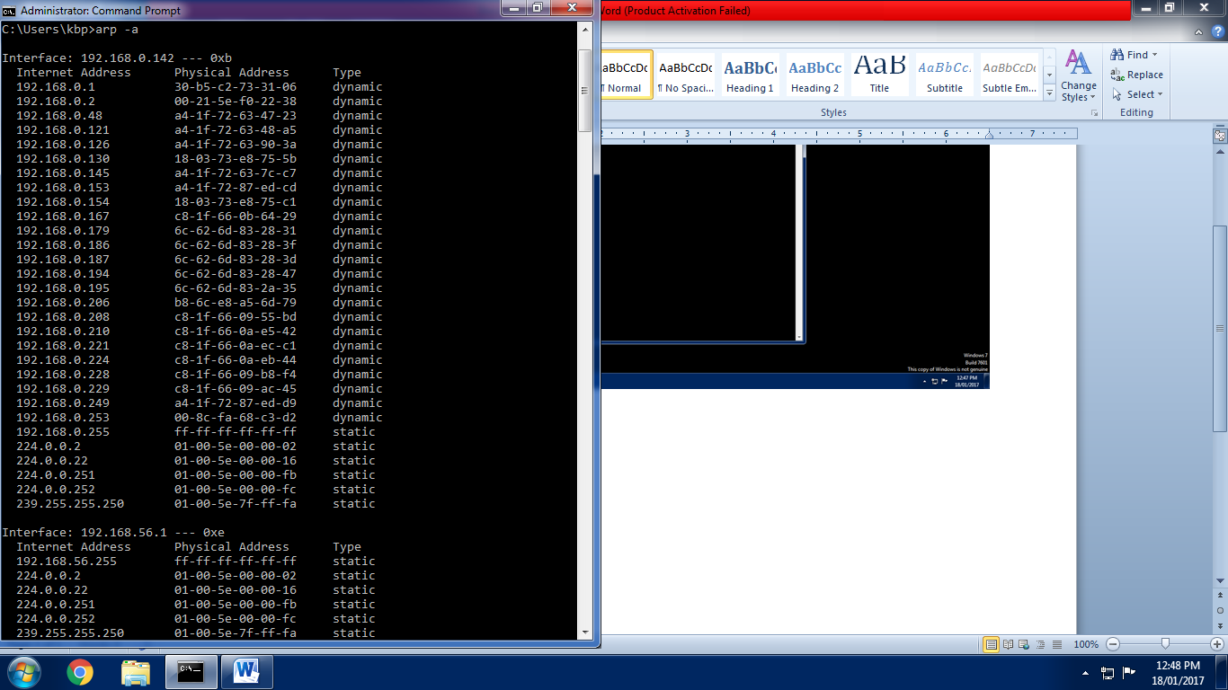

**arp –a -v**

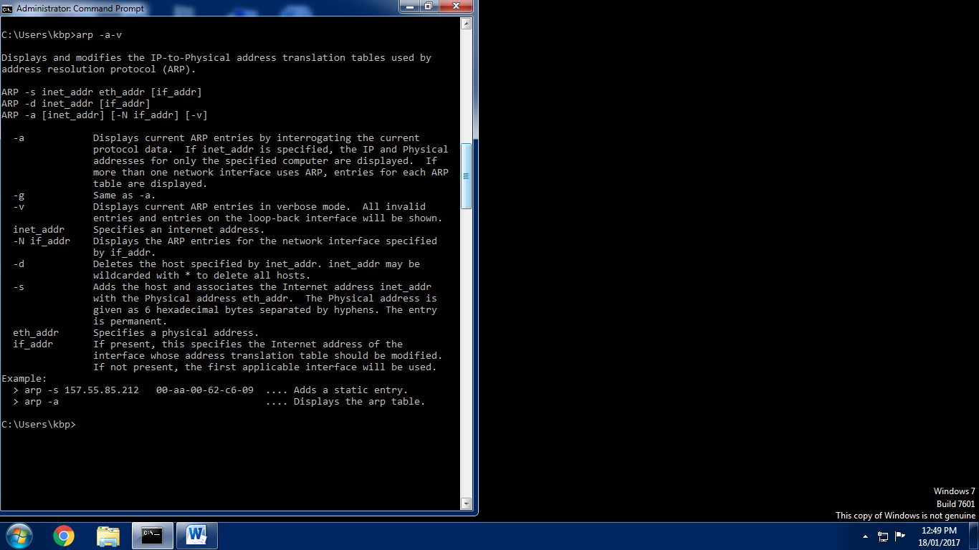

**ipconfig**

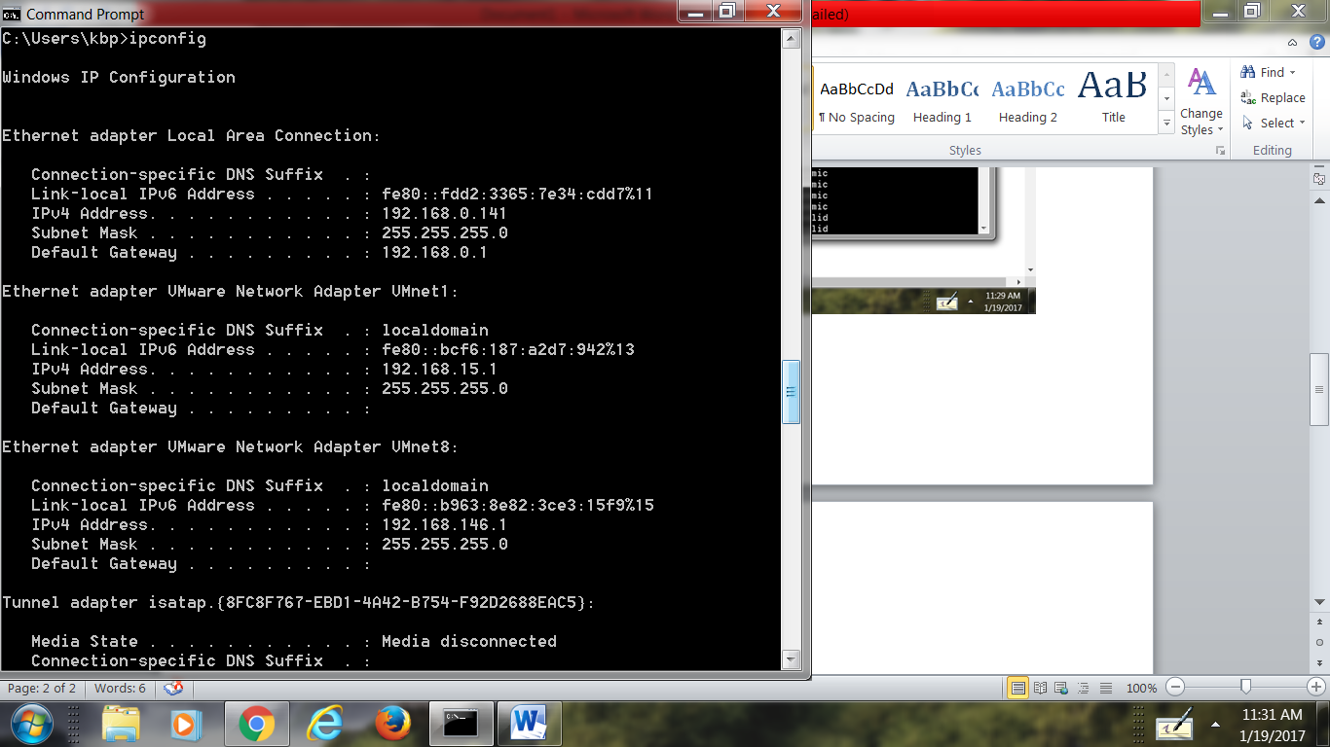

**ipconfig /release**

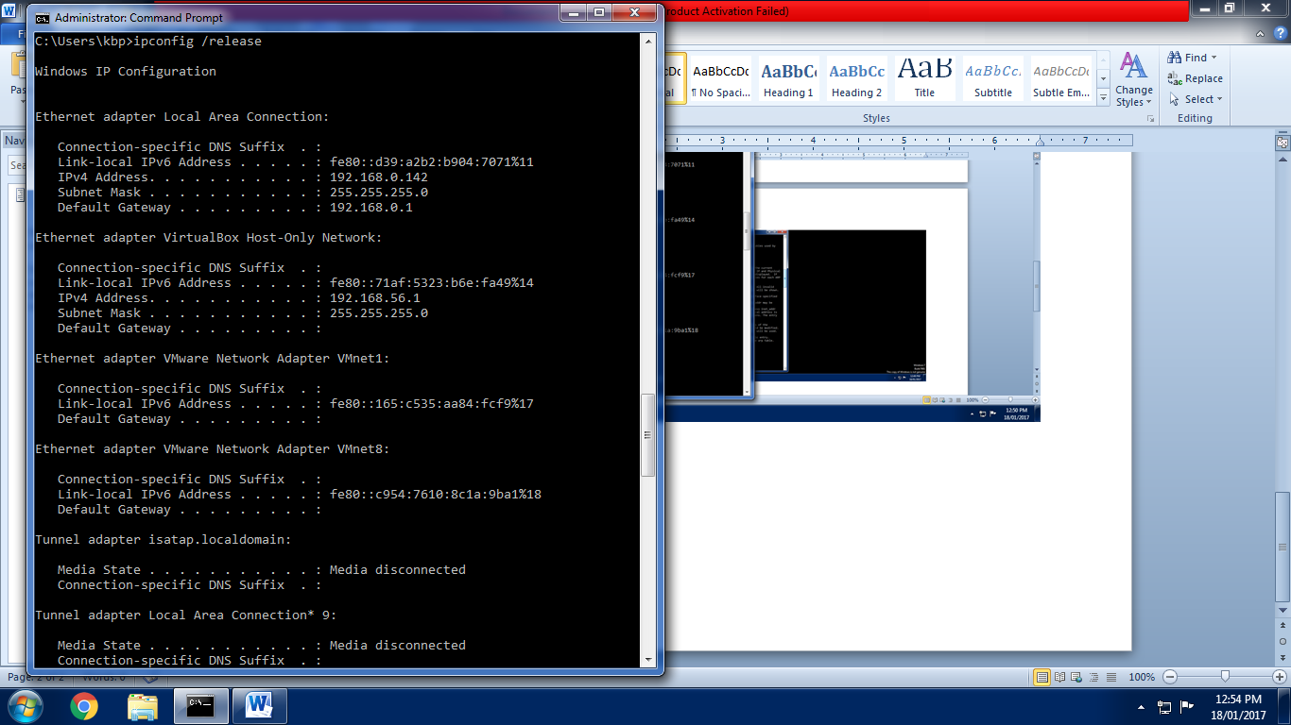

**ipconfig /renew**

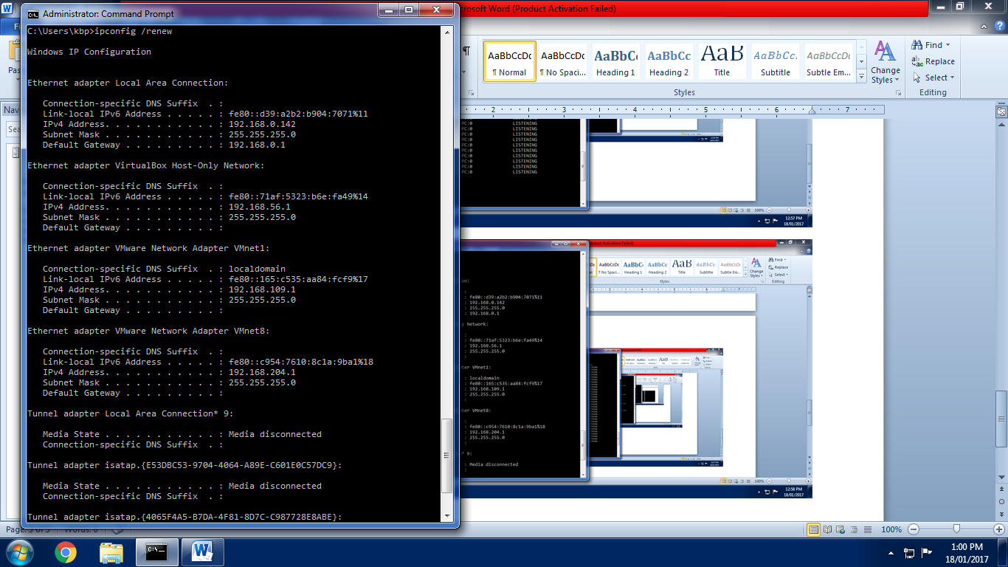

**netstat -a**

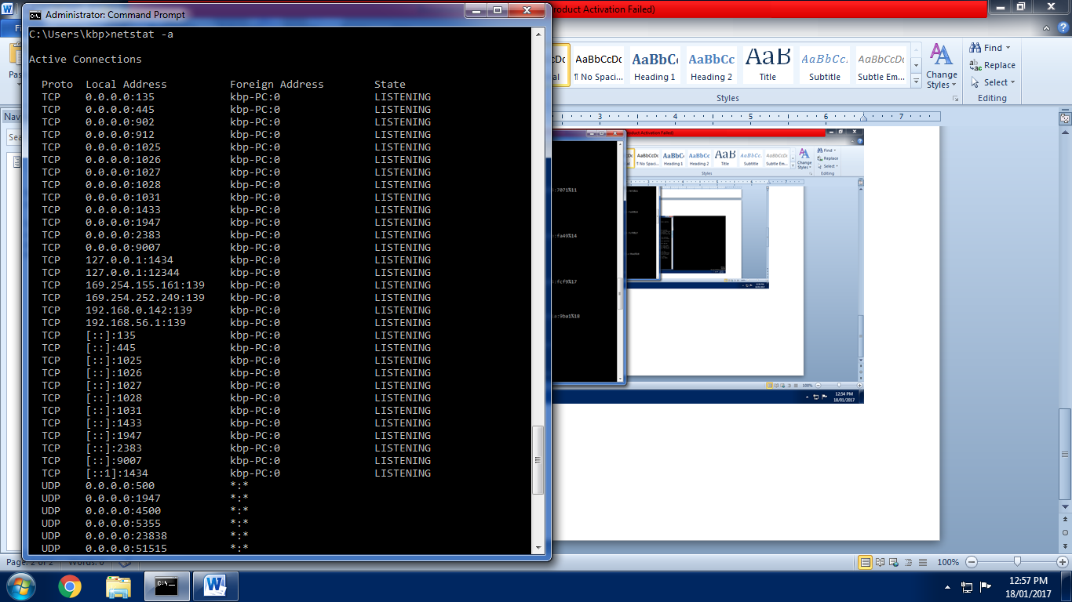

**netstat –R**

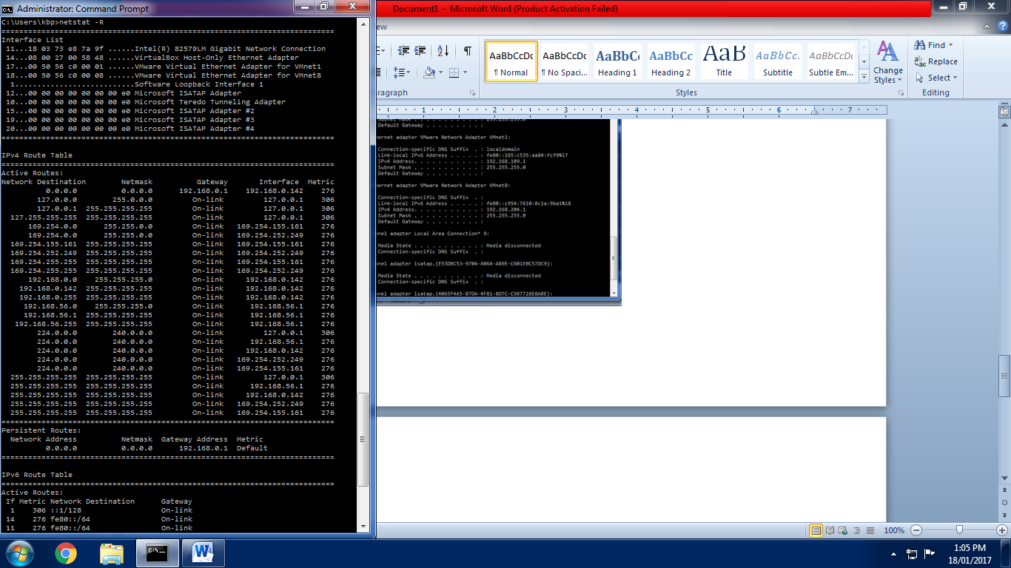

**netstat –e**

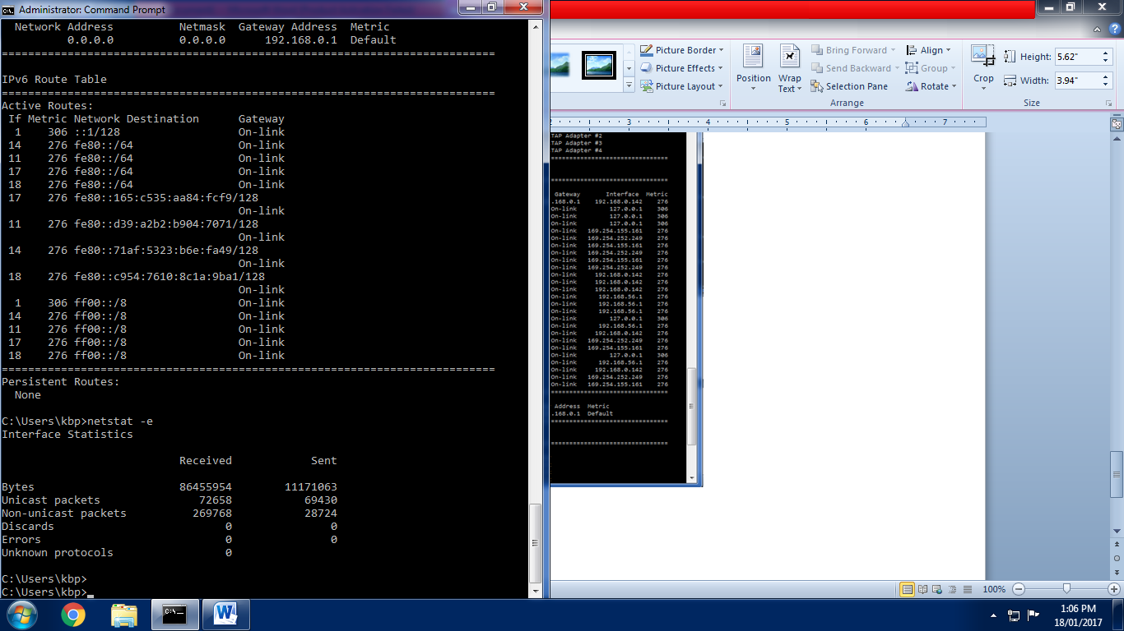

**Ping google.com**

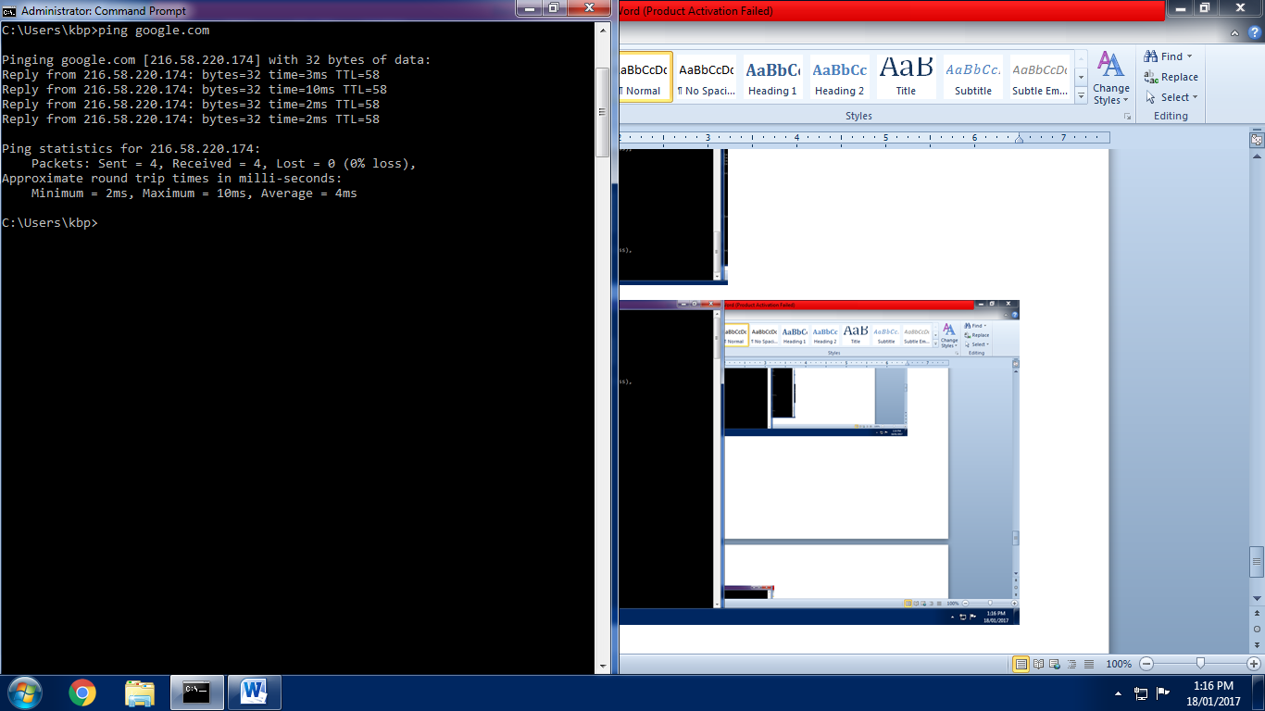

**ping -n 6 192.168.0.141**

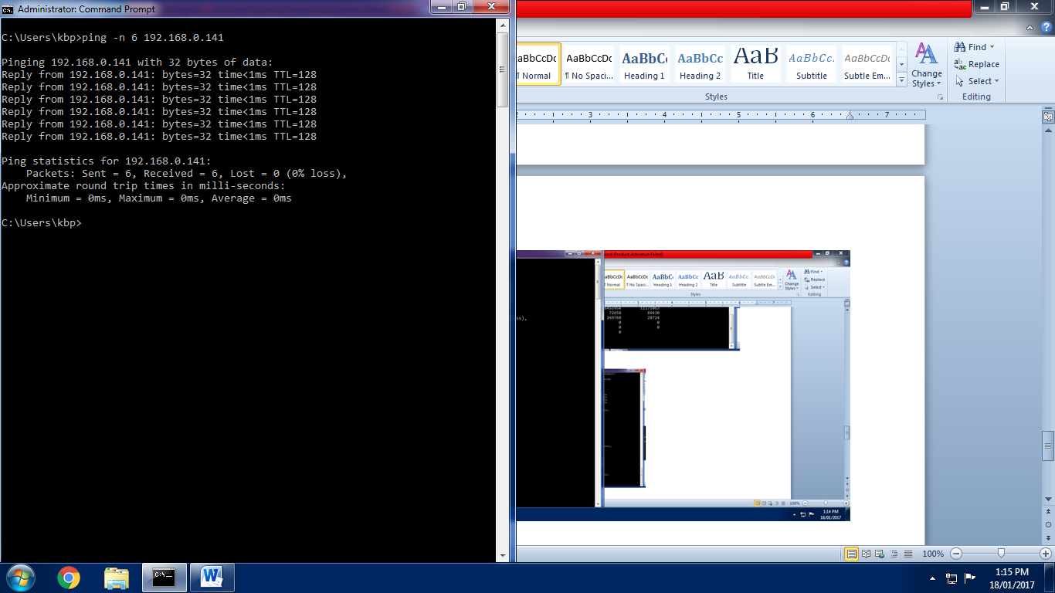

**ping –l 4 192.168.0.141**

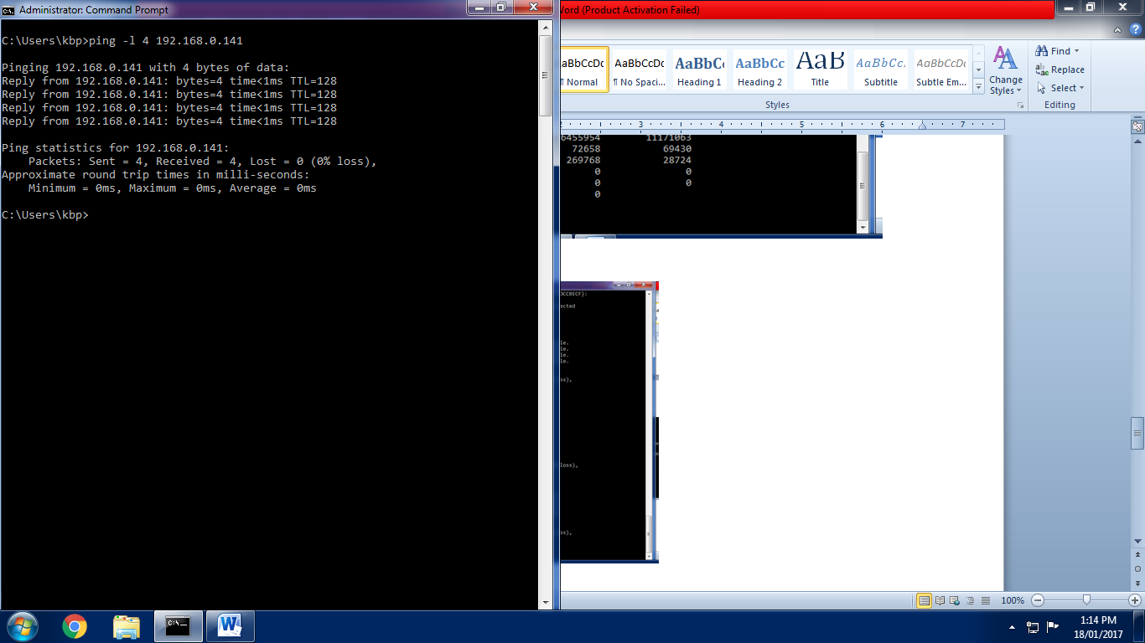

**ping –f 192.168.0.141**

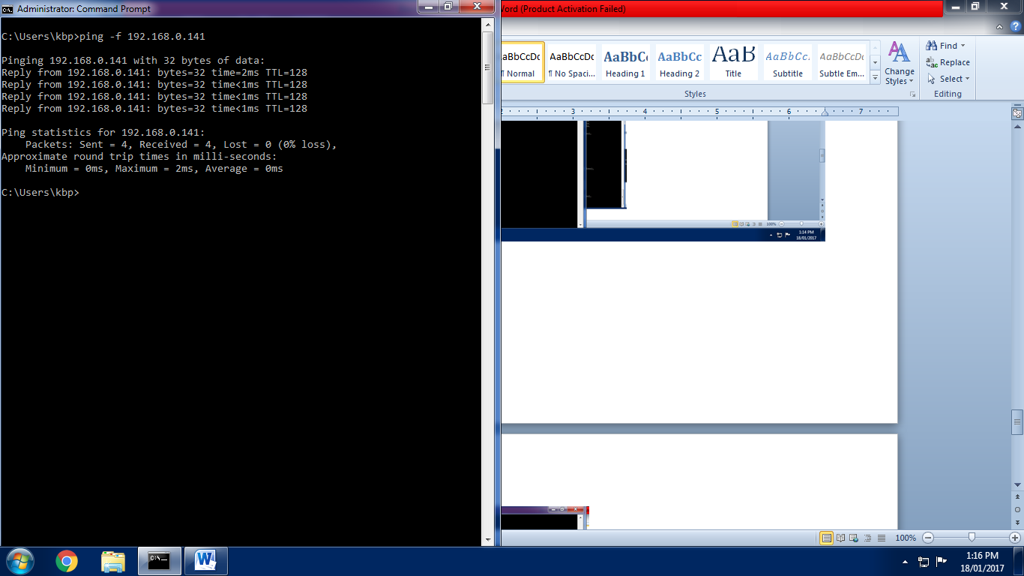

**ping –t 192.168.0.141**

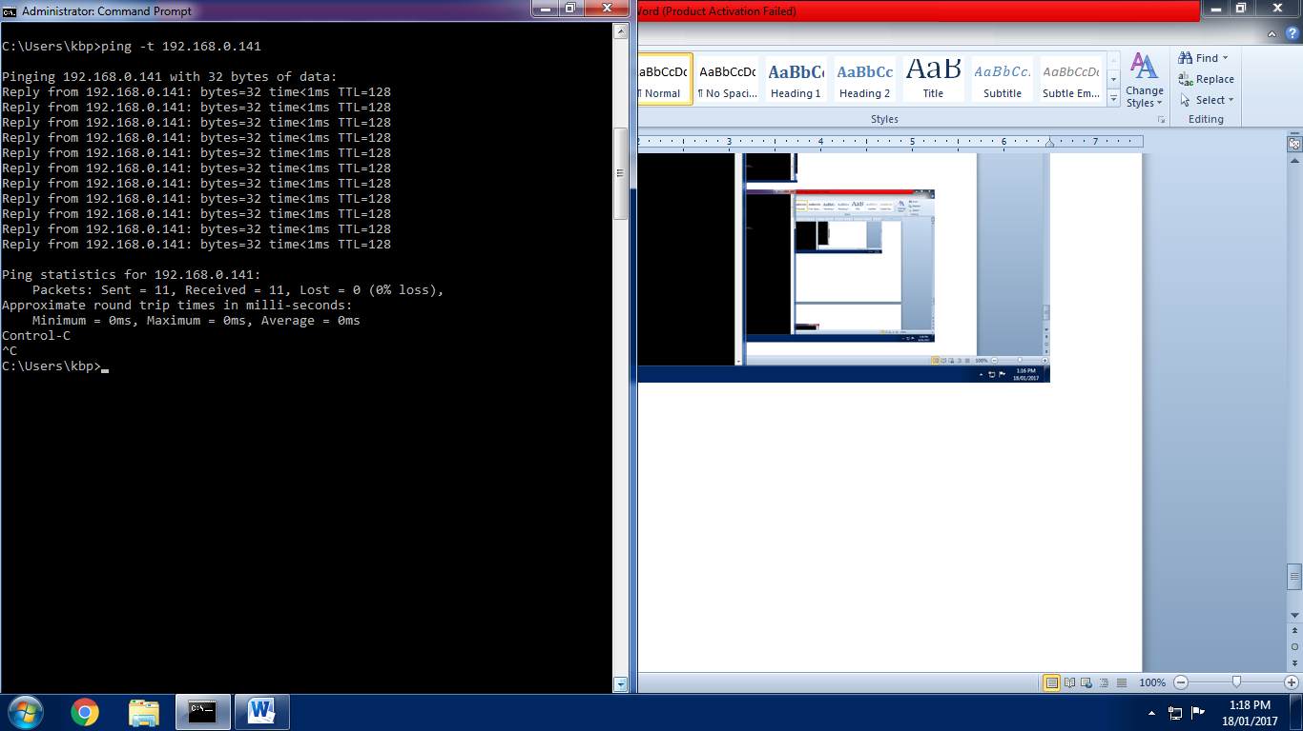

**route print**

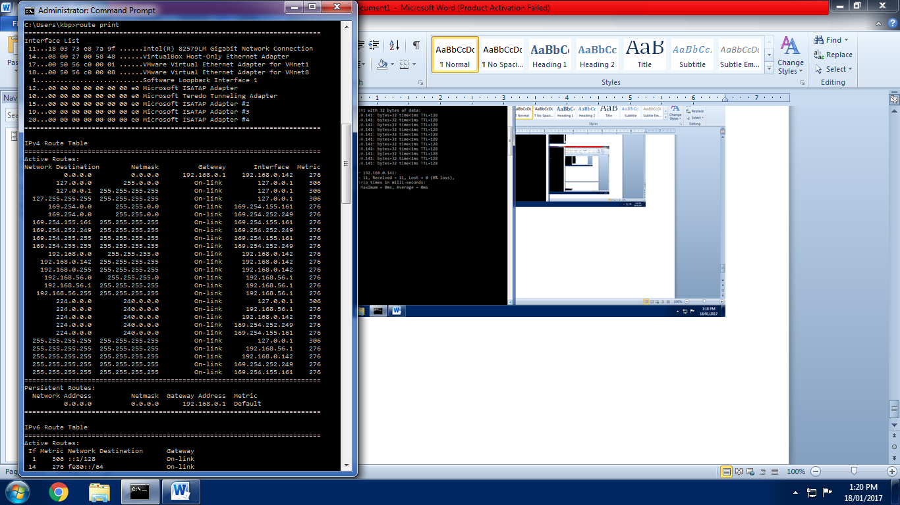

**ping print 192\***

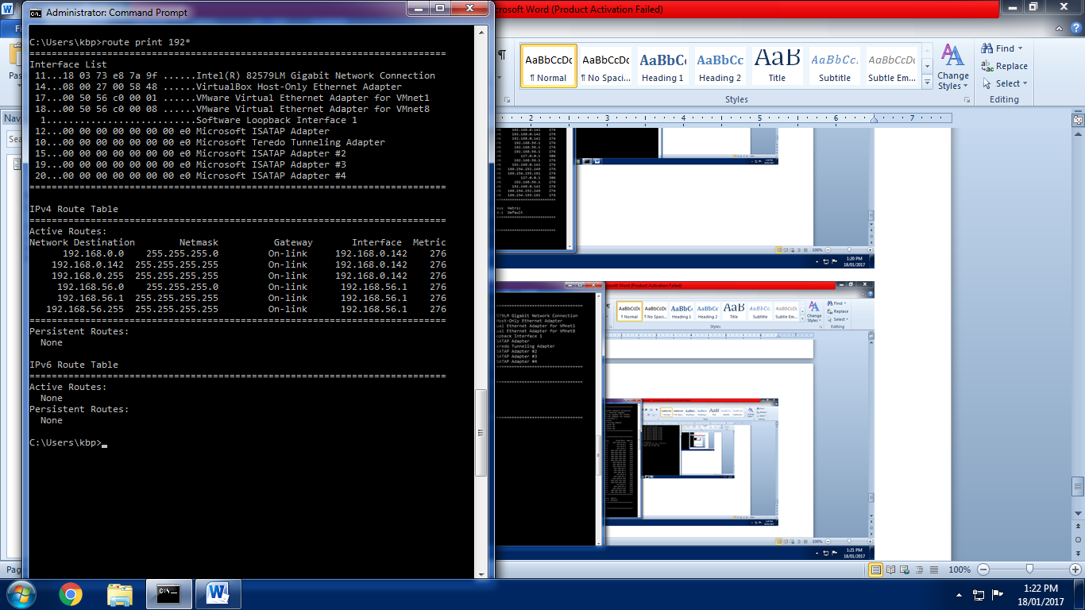

**tracert google.com**

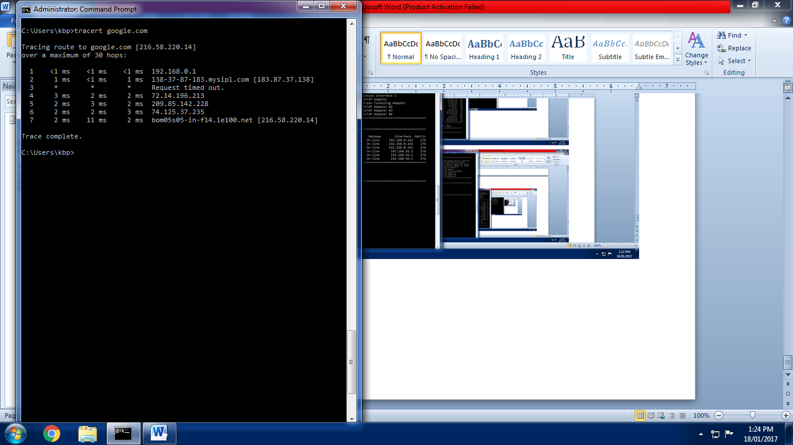

**tracert 103.213.213.226**

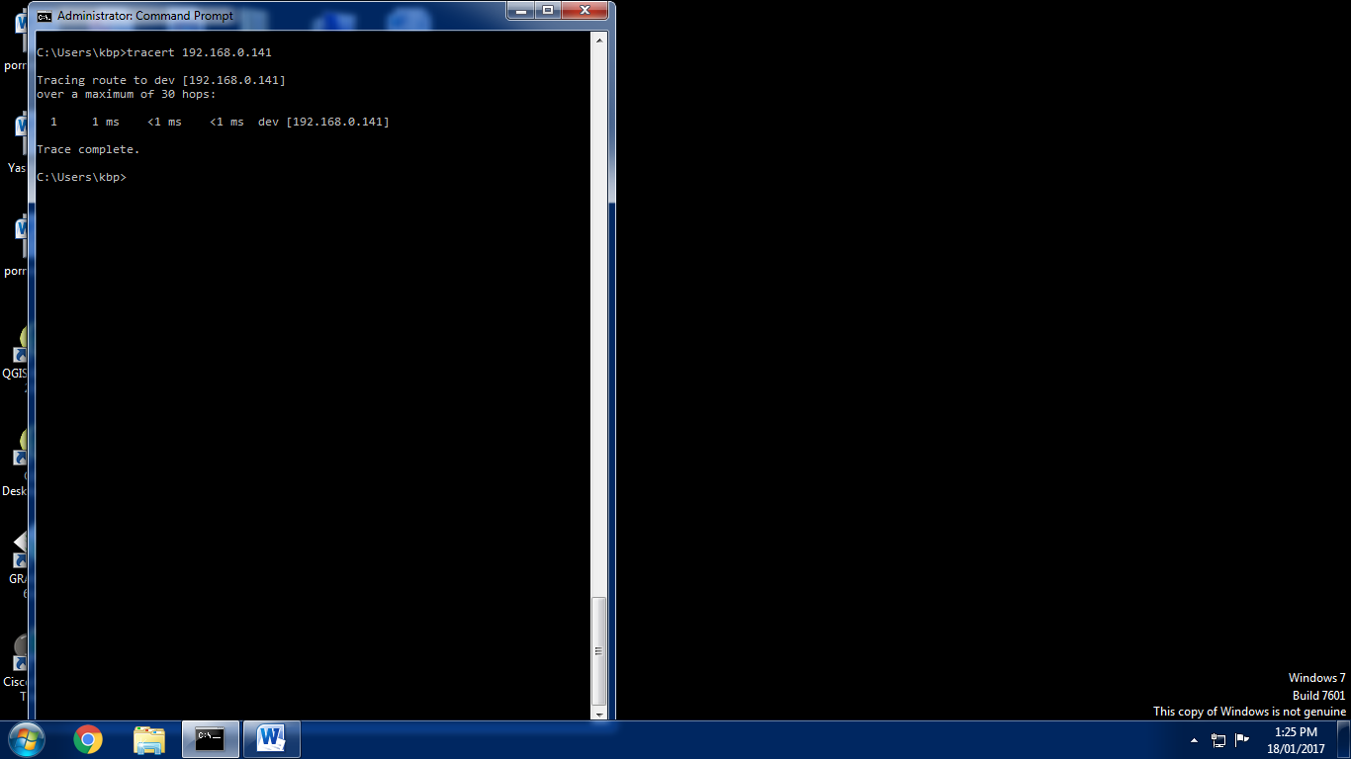

**Practical No-3**

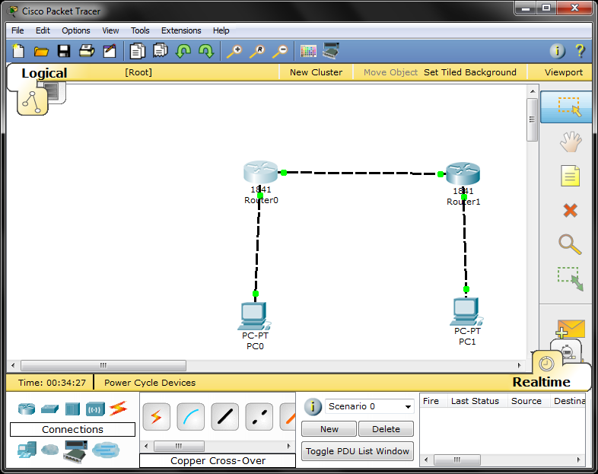

**Router r0**

Router>en

Router#config t

Enter configuration commands, one per line. End with CNTL/Z.

Router(config)#hostname r1

r1(config)#interface f0/0

r1(config-if)#ip address 10.0.0.1 255.0.0.0

r1(config-if)#no shut

%LINK-5-CHANGED: Interface FastEthernet0/0, changed state to up

r1(config-if)#exit

r1(config)#interface f0/1

r1(config-if)#ip address 20.0.0.1 255.0.0.0

r1(config-if)#no shut

%LINK-5-CHANGED: Interface FastEthernet0/1, changed state to up

%LINEPROTO-5-UPDOWN: Line protocol on Interface FastEthernet0/1, changed state to up

r1(config-if)#exit

r1(config)#

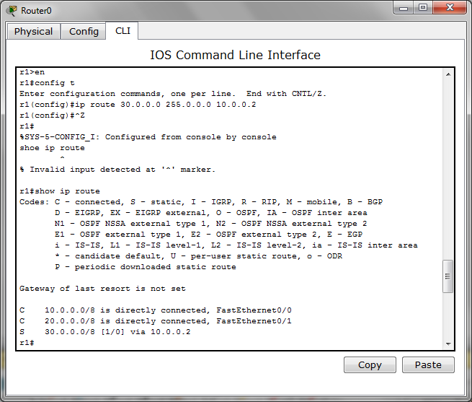

**Router r1**

Router>en

Router#config t

Enter configuration commands, one per line. End with CNTL/Z.

Router(config)#hostname r2

r2(config)#interface f0/0

r2(config-if)#ip address 10.0.0.2 255.0.0.0

r2(config-if)#no shut

%LINK-5-CHANGED: Interface FastEthernet0/0, changed state to up

%LINEPROTO-5-UPDOWN: Line protocol on Interface FastEthernet0/0, changed state to up

r2(config-if)#exit

r2(config)#interface f0/1

r2(config-if)#ip address 30.0.0.1 255.0.0.0

r2(config-if)#no shut

%LINK-5-CHANGED: Interface FastEthernet0/1, changed state to up

%LINEPROTO-5-UPDOWN: Line protocol on Interface FastEthernet0/1, changed state to up

r2(config-if)#exit

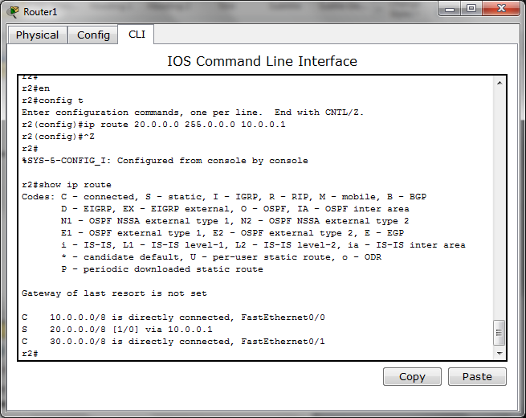

**Practical No-5 (OSPF)**

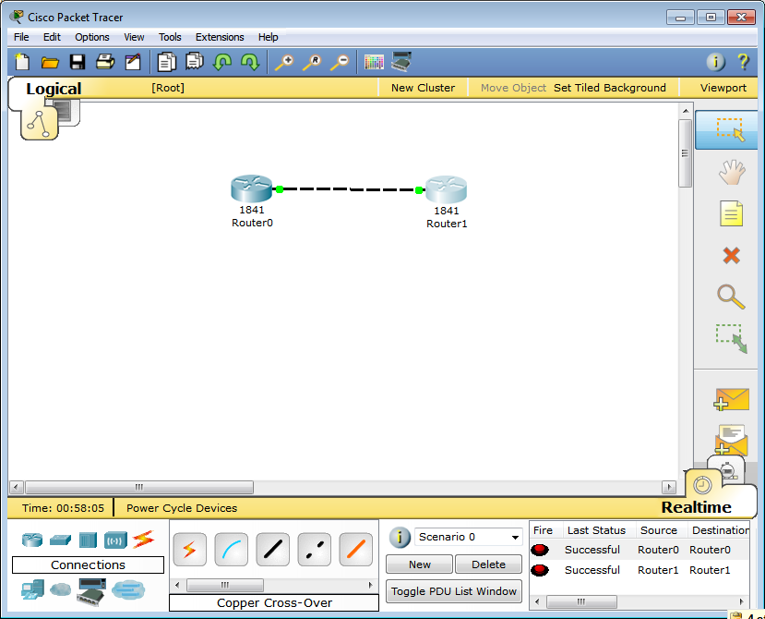

**Router 0**

Router>en

Router#config t

Enter configuration commands, one per line. End with CNTL/Z.

Router(config)#hostname r1

r1(config)#interface f0/0

r1(config-if)#ip address 192.1.1.1 255.255.255.0

r1(config-if)#no shut

%LINK-5-CHANGED: Interface FastEthernet0/0, changed state to up

r1(config-if)#exit

r1(config)#router ospf 1

r1(config-router)#network 192.1.1.1 0.0.0.255 area 0

r1(config-router)#^Z

r1#

%SYS-5-CONFIG_I: Configured from console by console

r1#show ip ospf neighbor

r1#

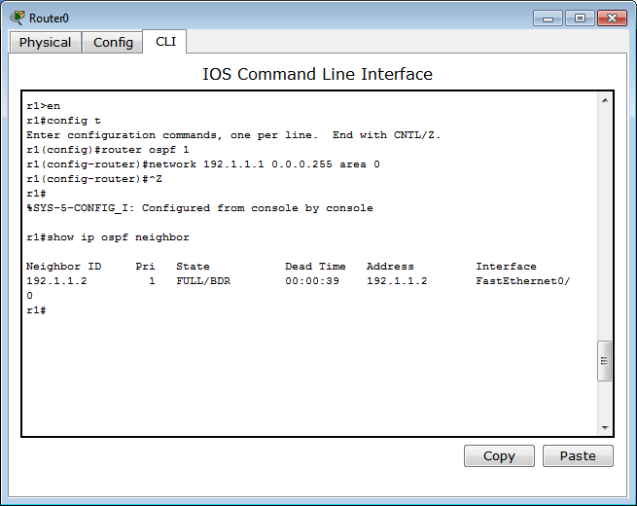

**Router 1**

Router>en

Router#config t

Enter configuration commands, one per line. End with CNTL/Z.

Router(config)#hostname r2

r2(config)#interface f0/0

r2(config-if)#ip address 192.1.1.2 255.255.255.0

r2(config-if)#no shut

%LINK-5-CHANGED: Interface FastEthernet0/0, changed state to up

%LINEPROTO-5-UPDOWN: Line protocol on Interface FastEthernet0/0, changed state to up

r2(config-if)#exit

r2(config)#router ospf 1

r2(config-router)#network 192.1.1.0 0.0.0.255 area 0

r2(config-router)#^Z

r2#

%SYS-5-CONFIG_I: Configured from console by console

r2#show

00:11:22: %OSPF-5-ADJCHG: Process 1, Nbr 192.1.1.1 on FastEthernet0/0 from LOADING to FULL, Loading Done

% Incomplete command.

r2#show ip ospf neighbor

Neighbor ID Pri State Dead Time Address Interface

192.1.1.1 1 FULL/DR 00:00:39 192.1.1.1 FastEthernet0/0

r2#

